ב"ה

פרטי הדיירים שיש להם יותר מ-4 מכשירים מושאלים, וכמות המכשירים שמושאלים אצלם:

SELECT r.resident_id, r.r_fname AS first_name, r.r_lname AS last_name, COUNT(m.equipment_id) AS total_devices

FROM residents r

JOIN medicalequipmentreceiving m ON r.resident_id = m.resident_id

GROUP BY r.resident_id, r.r_fname, r.r_lname

HAVING COUNT(m.equipment_id) > 4

ORDER BY r.resident_id;

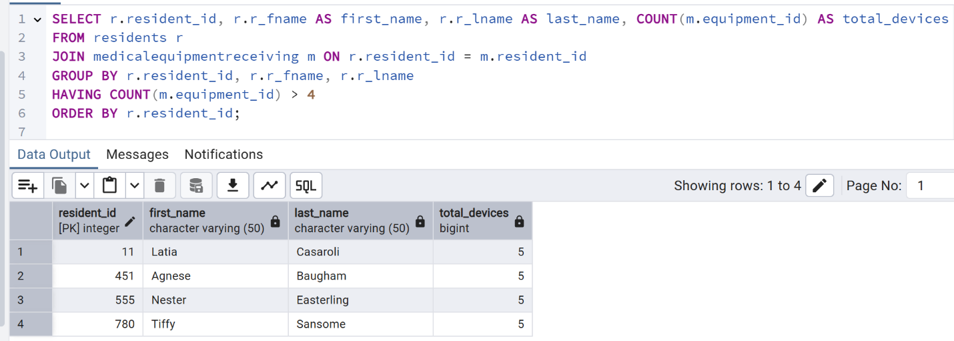

מציאת המכשיר שמושאל הכי הרבה, וכמות ההשאלות שלו:

SELECT

equipment_type,

COUNT(equipment_id) AS total_rentals

FROM

medicalequipmentreceiving

GROUP BY

equipment_type

HAVING

COUNT(equipment_id) >= ALL (

SELECT

COUNT(equipment_id)

FROM

medicalequipmentreceiving

GROUP BY

equipment_type

);

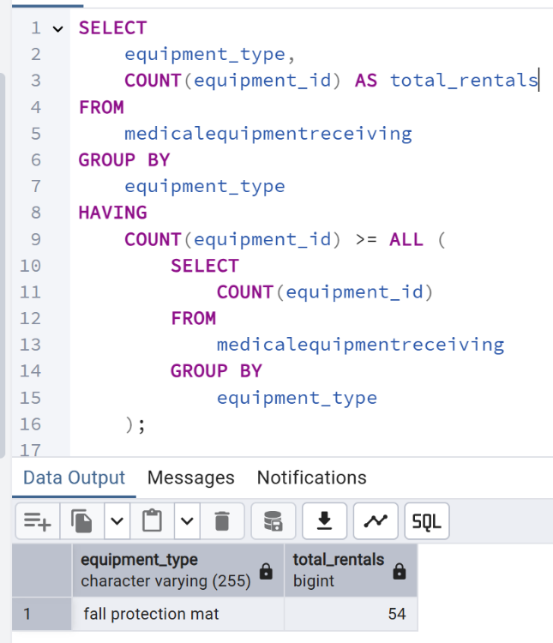

כמות המכשירים שמושאלים כרגע מכל סוג, ממוין לפי כמות:

SELECT

equipment_type AS device_type,

COUNT(*) AS currently_rented_count

FROM

medicalequipmentreceiving

WHERE

end_date IS NULL

GROUP BY

equipment_type

ORDER BY

currently_rented_count DESC;

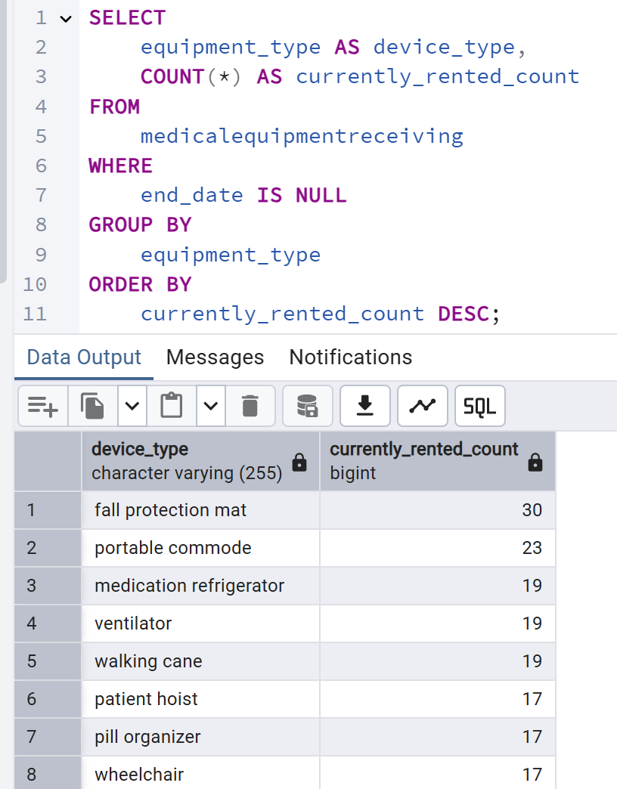

שמות הרופאים שביצעו הכי הרבה ביקורים:

SELECT

d.doc_id,

d.doc_fname AS first_name,

d.doc_lname AS last_name,

COUNT(mt.treatmenttime) AS total_treatments

FROM

doctors d

JOIN

medicaltreatments mt ON d.doc_id = mt.doc_id

WHERE

d.doc_id IN (

SELECT

mt.doc_id

FROM

medicaltreatments mt

GROUP BY

mt.doc_id

HAVING

COUNT(mt.treatmenttime) >= ALL (

SELECT

COUNT(mtt.doc_id)

FROM

medicaltreatments mtt

GROUP BY

mtt.doc_id

)

)

GROUP BY

d.doc_id, d.doc_fname, d.doc_lname

ORDER BY

total_treatments DESC;

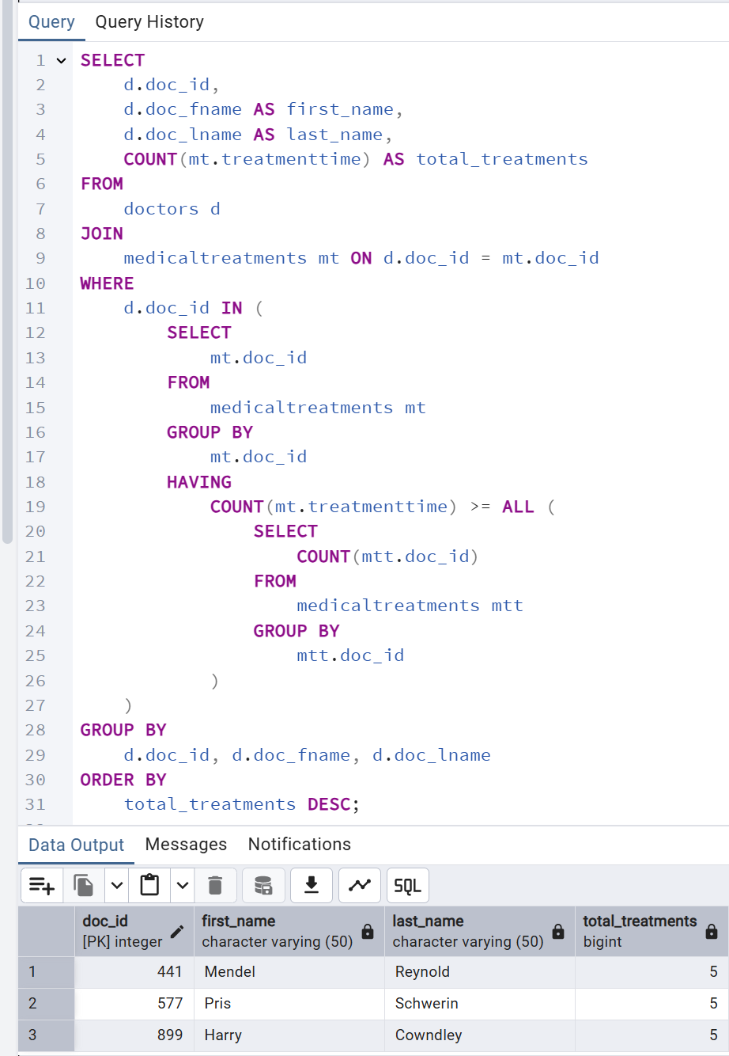

כמות הביקורים וכמות המכשירים שהיו בשימוש לפי שנים:

SELECT

COALESCE(r.year, t.year) AS year,

COALESCE(total_devices, 0) AS total_devices,

COALESCE(total_visits, 0) AS total_visits

FROM

(

SELECT EXTRACT(YEAR FROM start_date) AS year, COUNT(*) AS total_devices

FROM medicalequipmentreceiving

GROUP BY year

) AS r

FULL OUTER JOIN

(

SELECT EXTRACT(YEAR FROM treatmentdate) AS year, COUNT(*) AS total_visits

FROM medicaltreatments

GROUP BY year

) AS t

ON r.year = t.year

ORDER BY year;

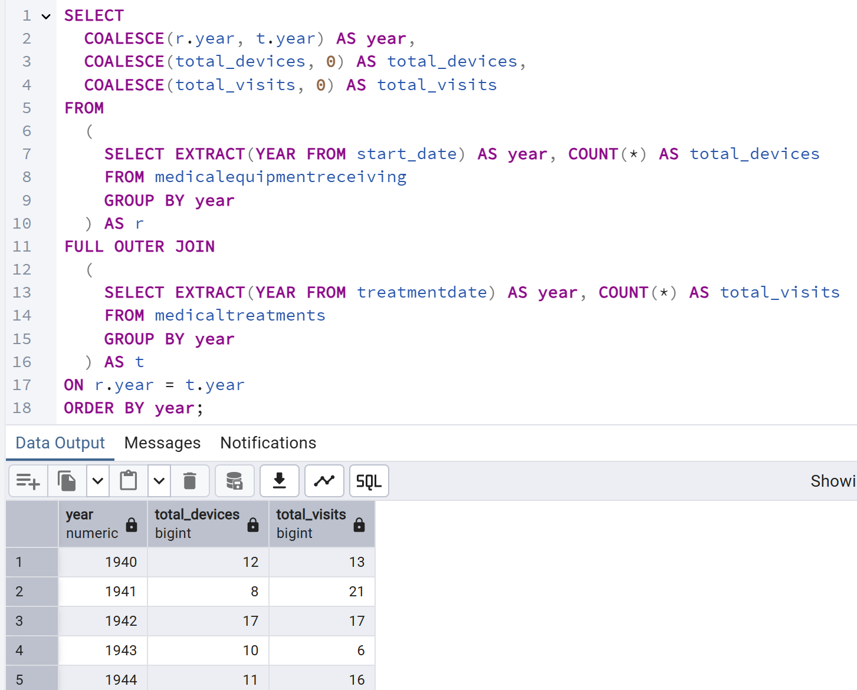

כמות התרופות שכל דייר לוקח:

SELECT resident_id, r_fname, r_lname, COUNT(medication_id) AS total_medications

FROM residentmedications

NATURAL JOIN residents

GROUP BY resident_id, r_fname, r_lname

ORDER BY total_medications DESC, resident_id;

תמונה שמכילה טקסט, צילום מסך, גופן, מספר

תוכן שנוצר על-ידי בינה מלאכותית עשוי להיות שגוי.

כל הפרטים על הדייר הכי מבוגר:

(ניתן להחליף את התנאי ולמצוא את כל הפרטים על כל דייר אחר שנבחר בעזרת שאילתה זו)

SELECT

residents.resident_id AS resident_id,

r_fname AS first_name,

r_lname AS last_name,

birthdate AS date_of_birth,

treatmentdate AS treatment_date,

medicaltreatments.doc_id AS doctor_id,

doc_fname AS doctor_first_name,

doc_lname AS doctor_last_name,

equipment_type AS equipment_type,

m_name AS medication_name

FROM

residents

LEFT JOIN medicaltreatments

ON residents.resident_id = medicaltreatments.resident_id

LEFT JOIN doctors

ON medicaltreatments.doc_id = doctors.doc_id

LEFT JOIN medicalequipmentreceiving

ON residents.resident_id = medicalequipmentreceiving.resident_id

LEFT JOIN residentmedications

ON residents.resident_id = residentmedications.resident_id

LEFT JOIN medications

ON residentmedications.medication_id = medications.medication_id

WHERE

birthdate <= ALL (

SELECT birthdate FROM residents

)

GROUP BY

residents.resident_id,

r_fname,

r_lname,

birthdate,

treatmentdate,

medicaltreatments.doc_id,

doc_fname,

doc_lname,

equipment_type,

m_name;

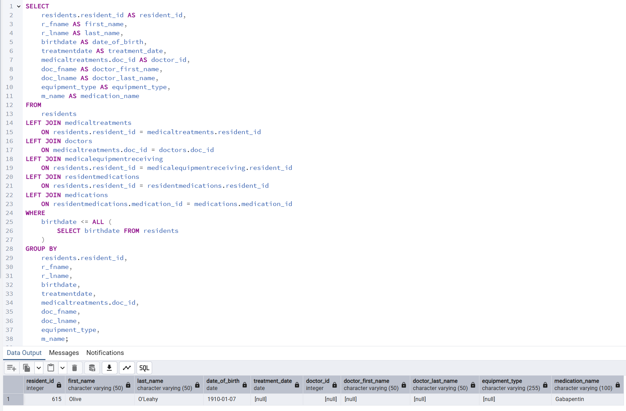

פרטי כל מטופל והביקורים שהיו אצלו:

SELECT

residents.resident_id AS resident_id,

r_fname AS first_name,

r_lname AS last_name,

birthdate AS date_of_birth,

treatmentdate AS treatment_date,

purpose AS treatment_purpose,

doc_fname AS doctor_first_name,

doc_lname AS doctor_last_name

FROM

residents

LEFT JOIN medicaltreatments

ON residents.resident_id = medicaltreatments.resident_id

LEFT JOIN doctors

ON medicaltreatments.doc_id = doctors.doc_id

GROUP BY

residents.resident_id,

r_fname,

r_lname,

birthdate,

treatmentdate,

doc_fname,

doc_lname,

purpose

ORDER BY

residents.resident_id,

treatmentdate;

תמונה שמכילה טקסט, צילום מסך, מספר, מקביל

תוכן שנוצר על-ידי בינה מלאכותית עשוי להיות שגוי.